Features of software quality

1. Degree of excellence
2. Conformance to specifications
3. Fitness for intended use
4. Life of product
5. Cost of product

To improve quality of product

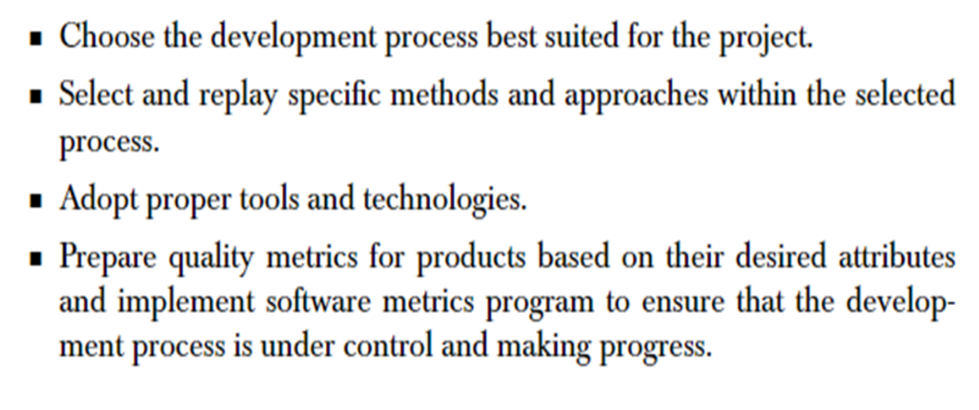

| **Parameters** | **Quality Assurance (QA)** | **Quality Control (QC)** |
| --- | --- | --- |
| **Objective** | It focuses on providing assurance that the quality requested will be achieved. | It focuses on fulfilling the quality requested. |
| **Technique** | It is the technique of managing quality. | It is the technique to verify quality. |
| **Involved in which phase?** | It is involved during the development phase. | It is not included during the development phase. |
| **Program execution is included?** | It does not include the execution of the program. | It always includes the execution of the program. |
| **Type of tool** | It is a managerial tool. | It is a corrective tool. |
| **Process/ Product-oriented** | It is process oriented. | It is product oriented. |
| **Aim** | The aim of quality assurance is to prevent defects. | The aim of quality control is to identify and improve the defects. |
| **Order of execution** | It is performed before Quality Control. | It is performed after the Quality Assurance activity is done. |
| **Technique type** | It is a preventive technique. | It is a corrective technique. |
| **Measure type** | It is a proactive measure. | It is a reactive measure. |
| **SDLC/ STLC?** | It is responsible for the entire software development life cycle. | It is responsible for the software testing life cycle. |
| **Activity level** | QA is a low-level activity that identifies an error and mistakes that QC cannot. | It is a high-level activity that identifies an error that QA cannot. |
| **Focus** | Pays main focus is on the intermediate process. | Its primary focus is on final products. |
| **Team** | All team members of the project are involved. | Generally, the testing team of the project is involved. |
| **Aim** | It aims to prevent defects in the system. | It aims to identify defects or bugs in the system. |
| **Time consumption** | It is a less time-consuming activity. | It is a more time-consuming activity. |
| **Which statistical technique was applied?** | Statistical Process Control (SPC) statistical technique is applied to Quality Assurance. | Statistical Quality Control (SQC) statistical technique is applied to Quality Control. |
| **Example** | Verification | Validation |

Mcalls quality factors

1. Product operation
2. Correctness
3. Efficiency
4. Integrity
5. Reliability
6. Usability
7. Product revision
8. Maintainability
9. Flexibility
10. Testability
11. Product transition
12. Portability
13. Reusability
14. Interoperability

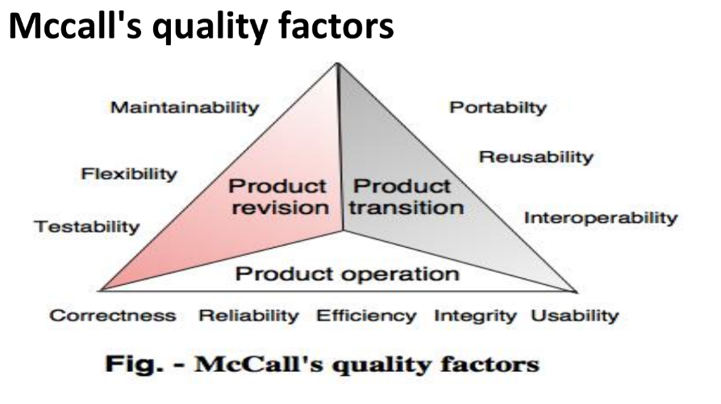

CMM

